|  |  |
| --- | --- |
| ACTIVITY | DATA TYPE |
| Number of beatings from Wife | Numerical(Discrete) |
| Results of rolling a dice | Numerical (Discrete) |
| Weight of a person | Numerical (Continuous) |
| Weight of Gold | Numerical (Continuous) |
| Distance between two places | Numerical (Continuous) |
| Length of a leaf | Numerical (Continuous) |
| Dog's weight | Numerical (Continuous) |
| Blue Color | Categorical(Nominal) |
| Number of kids | Numerical (Discrete) |
| Number of tickets in Indian railways | Numerical (Discrete) |
| Number of times married | Numerical (Discrete) |
| Gender (Male or Female) | Categorical(Nominal) |

Name: GUVVALA SOMASEKHAR REDDY mail: [**showmove5697@gmail.com**](mailto:showmove5697@gmail.com)

**Q1) Identify the Data type for the Following:**

**Q2) Identify the Data types, which were among the**

**Nominal, Ordinal, Interval, Ratio.**

|  |  |
| --- | --- |
| DATA | DATA TYPE |
| Gender | Nominal |
| High School Class Ranking | Ordinal |
| Celsius Temperature | Interval |
| Weight | Ratio |
| Hair Color | Nominal |
| Socioeconomic Status | Ordinal |
| Fahrenheit Temperature | Interval |
| Height | Ratio |
| Type of living accommodation | Nominal |
| Level of Agreement | Ordinal |
| IQ(Intelligence Scale) | Interval |
| Sales Figures | Ratio |
| Blood Group | Nominal |
| Time Of Day | Ordinal |
| Time on a Clock with Hands | Interval |
| Number of Children | Nominal |
| Religious Preference | Nominal |
| Barometer Pressure | Interval |
| SAT Scores | Interval |
| Years of Education | Ratio |

**Q3) Three Coins are tossed, find the probability that two heads and one tail are obtained?**

ANS: The probability that two heads and one tail are obtained is **0.375**

Given 3 coins are tossed.

**Probability = Number of Favorable Outcomes / Total Number of Outcomes**

Number of Possible outcomes from each coin are 2, head – ‘H’ and tail – ‘T’.

Total observations: 8

{HHH, HHT, HTH, THH, TTT, TTH, THT, HTT}

Number of favorable cases: {HHT, HTH, THH} = 3

* The probability that two heads and one tail are obtained **3/8=0.375**

**Q4) Two Dice are rolled, find the probability that sum is**

**a) Equal to 1** ANS: **0**

**b) Less than or equal to 4 and** ANS: **1/6**

**c) Sum is divisible by 2 and 3** ANS: **1/6**

When Two Dice are rolled  
 Total observations: 6c1*6c1= 36

(1, 1), (1, 2), (1, 3), (1, 4), (1, 5), (1, 6),

(2, 1), (2, 2), (2, 3), (2, 4), (2, 5), (2, 6),

(3, 1), (3, 2), (3, 3), (3, 4), (3, 5), (3, 6),

(4, 1), (4, 2), (4, 3), (4, 4), (4, 5) (4, 6),

(5, 1), (5, 2), (5, 3), (5, 4), (5, 5), (5, 6),

(6, 1), (6, 2), (6, 3), (6, 4), (6, 5), (6, 6).

**Probability = Number of Favorable Outcomes / Total Number of Outcomes**

a. Is equal to 1   
Number of favorable case to get those sum 1 is 0

The probability that sum 1 is = 0/36 = **0**

b. Less than or equal to 4   
 Number of favorable cases to get those sum Less than or equal to 4 = 6  
 { (1,1),(1,2),(2,1),(1,3),(3,1),(2,2)}  
 The probability that cases to get those sum is Less than or equal to 4 = 6/36=**1/6**

c. Sum is divisible by 2 and 3   
 Number of favorable cases to get those sum is divisible by 2 and 3= 6  
 {(1, 5), (2, 4), (3, 3), (4, 2), (5, 1), (6, 6)}

The probability that case to get those sum is divisible by 2 and 3= 6/36 =**1/6**

**Q5) A bag contains 2 red, 3 green and 2 blue balls. Two balls are drawn at random. What is the probability that none of the balls drawn is blue?**

ANS: **10/21**

**Probability = Number of Favorable Outcomes / Total Number of Outcomes**

Total number of balls  
= (red 2 + green 3 + blue 2) = 7  
Let S be the sample space  
Then, n(S) = Number of ways of drawing 2 balls out of 7

n(S)=7C2=(7×6)(2×1)=21  
Let E = Event of 2 balls, none of which is blue  
∴ n(E) = Number of ways of drawing 2 balls out of (2 + 3) balls

n(E)=5C2 =(5×4)(2×1)=10

∴ The probability that none of the balls drawn is blue P(E)=n(E)/n(S)=10/21

**Q6) Calculate the Expected number of candies for a randomly selected child**

**Below are the probabilities of count of candies for children (ignoring the nature of the child-Generalized view)**

|  |  |  |
| --- | --- | --- |
| **CHILD** | **Candies count** | **Probability** |
| **A** | **1** | **0.015** |
| **B** | **4** | **0.20** |
| **C** | **3** | **0.65** |
| **D** | **5** | **0.005** |
| **E** | **6** | **0.01** |
| **F** | **2** | **0.120** |

**Child A – probability of having 1 candy = 0.015.**

**Child B – probability of having 4 candies = 0.20**

ANS: **3.09**

Expected number of candies for a randomly selected child

= ∑ P(x).E(x)

=1 * 0.015 + 4*0.20 + 3 *0.65 + 5*0.005 + 6 *0.01+ 2 * 0.12

= 0.015 + 0.8 + 1.95 + 0.025 + 0.06 + 0.24

= 3.090

= 3.09

**Expected number of candies for a randomly selected child = 3.09**

**Q7) Calculate Mean, Median, Mode, Variance, Standard Deviation, Range & comment about the values / draw inferences, for the given dataset**

* **For Points, Score, Weigh**

**Find Mean, Median, Mode, Variance, Standard Deviation, and Range and also Comment about the values/ Draw some inferences.**

**Use Q7.csv file**

ANS:

|  |  |  |  |  |  |  |
| --- | --- | --- | --- | --- | --- | --- |
|  | Mean | Median | Mode | Variance | STD | Range |
| Points | **3.596563** | **3.695000** | **3.92** | **0.285881** | **0.534679** | **1.63** |
| Score | **3.217250** | **3.325000** | **3.44** | **0.957379** | **0.978457** | **3.911** |
| Weigh | **17.848750** | **17.710000** | **17.02** | **3.193166** | **1.786943** | **8.4** |

* These mean, median and mode are approximately same in each individual.
* The data points are likely to frame normal distribution.

Code: 

**Q8) Calculate Expected Value for the problem below**

**a)The weights (X) of patients at a clinic (in pounds), are**

**108, 110, 123, 134, 135, 145, 167, 187, 199**

**Assume one of the patients is chosen at random. What is the Expected Value of the Weight of that patient?**

ANS: **145. 33**

Expected Value = ∑ (probability* Value)

∑ P(x).E(x)

There are 9 patients

Probability of selecting each patient = 1/9

|  |  |  |  |  |  |  |  |  |  |
| --- | --- | --- | --- | --- | --- | --- | --- | --- | --- |
| E(x) | 108 | 110 | 123 | 134 | 135 | 145 | 167 | 187 | 199 |
| P(x) | 1/9 | 1/9 | 1/9 | 1/9 | 1/9 | 1/9 | 1/9 | 1/9 | 1/9 |

Expected Value

= (1/9)108 + (1/9)110 + (1/9)123 + (1/9)134 + (1/9)135+ (1/9)145

+ (1/9)167 + (1/9)187 + (1/9)199

= (1/9) (108 + 110 + 123 + 134 + 135 + 145 + 167 + 187 + 199)

= 145.33

Expected Value of the Weight of that patient = 145.33

**Q9) Calculate Skewness, Kurtosis & draw inferences on the following data**

**Cars speed and distance. Use Q9_a.csv**

ANS:

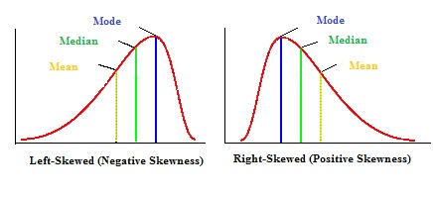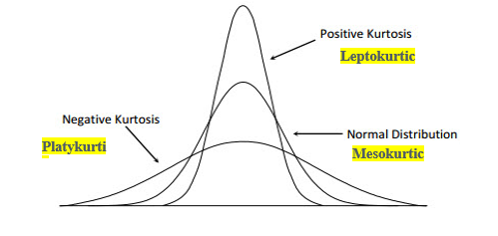

|  |  |  |
| --- | --- | --- |
|  | **Skewness** | **Kurtosis** |
| **Speed** | -0.1175 | -0.509 |
| **distance** | 0.8069 | 0.4051 |

* Speed is negatively skewed and the distributionhas its tail on the left side of thedistribution
* Distance is positively skewed and it has tail on the on the right side of the distribution
* Kurtosis of speed is negative then kurtosis less than normal distribution and it has lower tail
* Kurtosis of distance is positive then kurtosis more than normal distributionand it has upper skinny tails

Code:

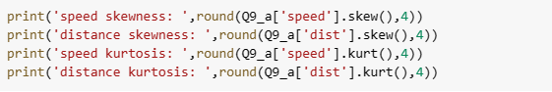

|  |  |  |
| --- | --- | --- |
|  | **Skewness** | **Kurtosis** |
| **SP** | 1.6115 | 2.9773 |
| **WT** | -0.6148 | 0.9503 |

**SP and Weight (WT) Use Q9_b.csv**

* WT is negatively skewed and the distributionhas its tail on the left side of thedistribution
* SP is positively skewed and it has tail on the on the right side of the distribution
* Both SP and WT have positive kurtosis implies, so the kurtosis more than normal distribution and they have long and skinny tails

Code:

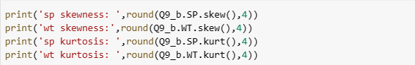

**Q10) Draw inferences about the following boxplot & histogram**



**ANS:**

**Histogram:**

* This is an asymmetric distribution.
* It is a right tailed and positively skewed.
* Outliers can find in the right end.

**Boxplot:**



* This is an asymmetric distribution.
* Outliers are on the right extreme side.

Q11) Suppose we want to estimate the average weight of an adult male in Mexico. We draw a random sample of 2,000 men from a population of 3,000,000 men and weigh them. We find that the average person in our sample weighs 200 pounds, and the standard deviation of the sample is 30 pounds. Calculate 94%, 98%, 96% confidence interval?

**ANS:**

The confidence interval for 94% is: [143.5762, 256.4238]

The confidence interval for 98% is: [130.2096, 269.7904]

The confidence interval for 96% is: [138.3875, 261.6125]

Code:



**Q12)** Below are the scores obtained by a student in tests

**34,36,36,38,38,39,39,40,40,41,41,41,41,42,42,45,49,56**

1) Find mean, median, variance, standard deviation.   
ANS:  
Mean : 41   
Median : 40.5   
Variance : 24.11   
Standard Deviation : 4.91  
Code:

a = [34,36,36,38,38,39,39,40,40,41,41,41,41,42,42,45,49,56]

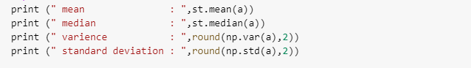

2) What can we say about the student marks?

ANS:

* The average marks of students are 41.
* Min and max marks are 34 and 56 respectively.
* Maximum students have scored marks between 38 and 42.

**Q13) what is the nature of skewness when mean, median of data are equal?**

ANS: It is following normal distribution without skewness.

**Q14) what is the nature of skewness when mean > median?**

ANS: Then the distribution will be negatively skewed.

**Q15) what is the nature of skewness when median > mean?**

ANS: Then the distribution will be positively skewed.

**Q16) what does positive kurtosis value indicates for a data?**

ANS: Plot of data will have sharp thin peak and data will be denser in short range.

**Q17) what does negative kurtosis value indicates for a data?**

ANS: Plot of data will have broader peak and data will be spread over wide range.

**Q18) Answer the below questions using the below boxplot visualization.**



**What can we say about the distribution of the data?**

ANS:

* This is negatively skewed and with outliers on the left side of median.
* The median is present around 15.

**What is nature of skewness of the data?**

ANS: Negatively Skewed

**What will be the IQR of the data (approximately)?**

ANS: 8

**Q19) Comment on the below Boxplot visualizations?**



**Draw an Inference from the distribution of data for Boxplot 1 with respect Boxplot 2.**

ANS:

* These two plots are normal distributed with having their median around 260
* Both of the plots do not have outliers and these are not skewed.
* Plot 2 is covering more area (or range) than Plot 1.

**Q 20) Calculate probability from the given dataset for the below cases**

**Data _set: Cars.csv**

**Calculate the probability of MPG of Cars for the below cases.**

**MPG <- Cars $MPG**

**a)P(MPG>38)** ANS: 0.3476

**b)P(MPG<40)** ANS: 0.7293

**c)P (20<MPG<50)** ANS: 0.8989

Code:

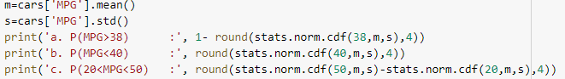

**Q 21) Check whether the data follows normal distribution**

**A) Check whether the MPG of Cars follows Normal Distribution**

**Dataset: Cars.csv**

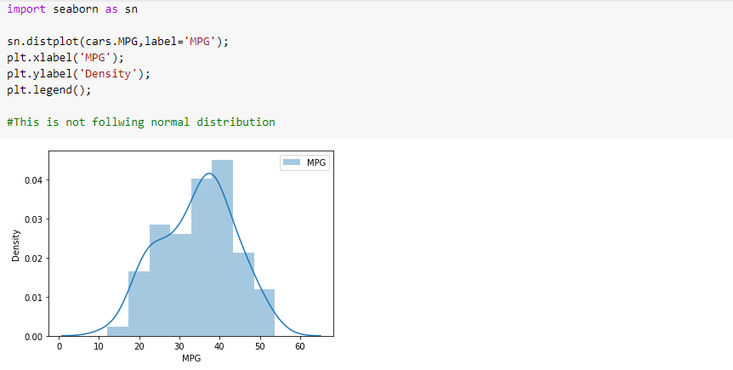

**B) Check Whether the Adipose Tissue (AT) and Waist Circumference(Waist) from wc-at data set follows Normal Distribution**

**Dataset: wc-at.csv**

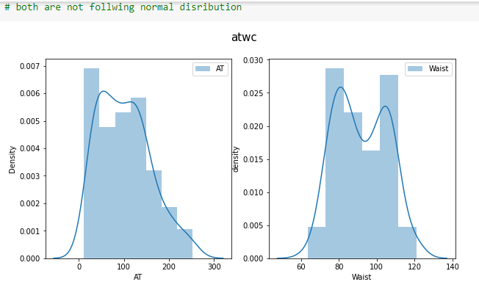

Code:

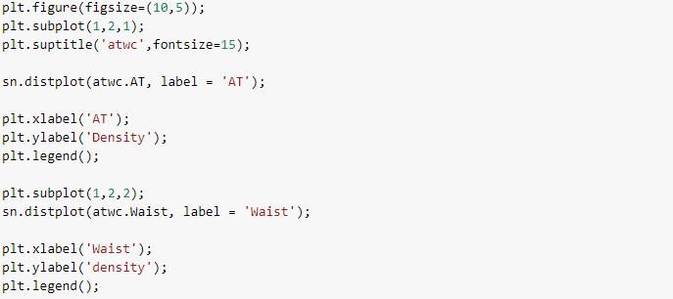

22) Calculate the Z scores of 90% confidence interval,94% confidence interval, 60% confidence interval

ANS:

The Z score of 90% confidence interval: 1.2816

The Z score of 94% confidence interval: 1.5548

The Z score of 60% confidence interval: 0.2533

Code:

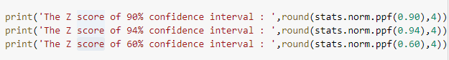

**Q 23) Calculate the t scores of 95% confidence interval, 96% confidence interval, 99% confidence interval for sample size of 25**

**ANS:**

The t score of 95% confidence interval for sample size of 25: 1.7109

The t score of 96% confidence interval for sample size of 25: 1.8281

The t score of 99% confidence interval for sample size of 25: 2.4922

Code:

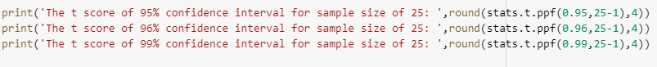

**Q 24) A Government company claims that an average light bulb lasts 270 days. A researcher randomly selects 18 bulbs for testing. The sampled bulbs last an average of 260 days, with a standard deviation of 90 days. If the CEO's claim were true, what is the probability that 18 randomly selected bulbs would have an average life of no more than 260 days.**

**Hint: rcode 🡪 pt(tscore,df) df 🡪 degrees of freedom**

ANS: T- Score: -0.4714

The probability that 18 randomly selected bulbs would have

an average life of no more than 260days : 0.3217

Code:

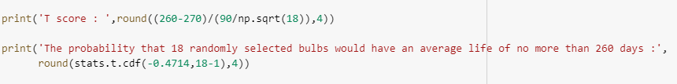

------ **THANK YOU** -----